Digital Logic Design Section 19134– Fall 2025
Lab 2 – The Digital Design Process with SimUAid
Team 16
Carol Morales and Anaya Scott
Overview: Goals of the Lab
In this lab we will learn to simplify Boolean expressions using techniques such as the Distributive Laws, Idempotent Laws and DeMorgan’s Law. We will use the SimUAid Software to simulate the circuit given to match the simplified version of the equations.

Step-by-Step Procedures and Results
Part 1: Simplifying Boolean Expressions Using Table 2-3 and 2-4
Questions:
- Simplify F₁ until it matches F_{1S}. Indicate which law or theorem you used on each step. You may either type the steps or use a figure of handwritten work.
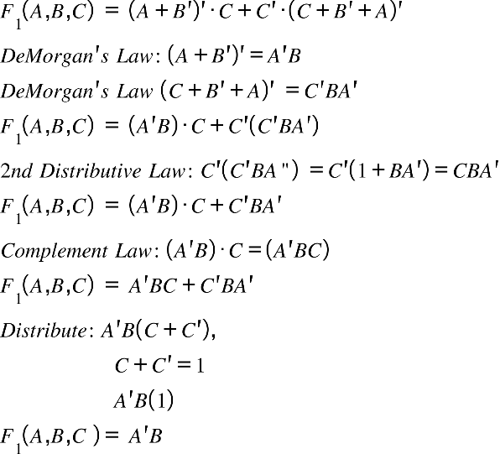
- Sketch each circuit by hand or with SimUAid/LTspice using AND, OR, or NOT.
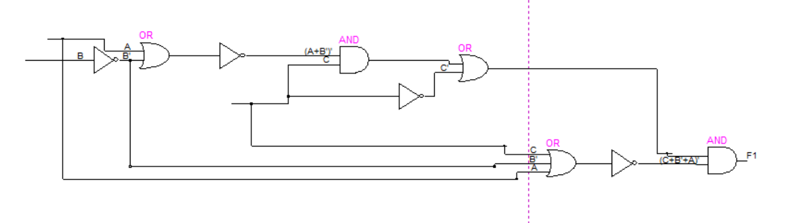
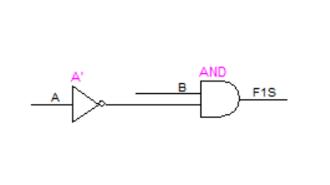
- Which TTL chips from your kit do you need to make F₁ and F_{1S}?
TTL chips to make F₁ are a 7404 inverter, quad 2-input OR (7432) and a quad 2-input AND (7408). For F_{1S} the chips needed would be an inverter (7404) and quad 2-input AND (7408).
- What are the benefits of simplifying F₁?
By simplifying F₁ we reduce the number of TTL chips needed to simulate that equation.

Part 2: Simplification using New Logic Gates using Section 3.2

- Simplify F₂ until it matches F_{2S}. Indicate which law or theorem you used on each step. You may either type the steps or use a figure of handwritten work.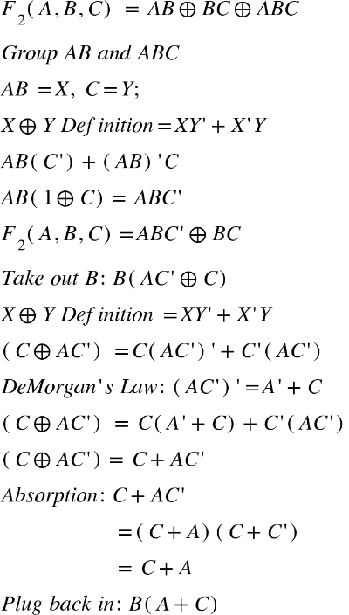
- Sketch each circuit by hand or with SimUAid/LTspice using AND, OR, or NOT.
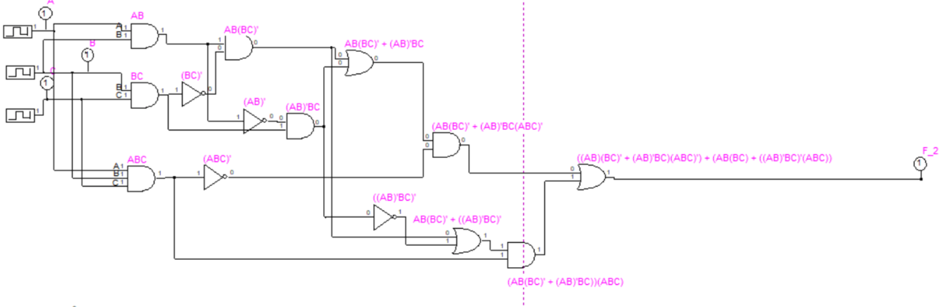
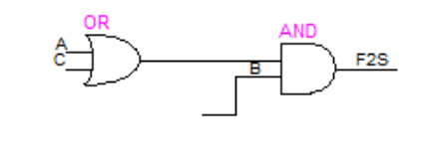
- Which TTL chips from your kit do you need to make F₂ and F_{2S}?
TTL chips needed to make F₂ are a quad 2-input AND (7408) and a quad 2-input XOR (7486). For F_{2S} the chips we would need are a quad 2-input OR (7432) and a quad 2-input AND (7408)
- If the number of input combinations is determined by the function 2^{𝑛}, where n is the number of inputs for a given Boolean expression, how many combinations of inputs are possible in total for F₂?
There would be 8 possible input combinations in total for F₂
Part 3:Creating both F2 and F2S Boolean Expressions with New SimUAid Techniques
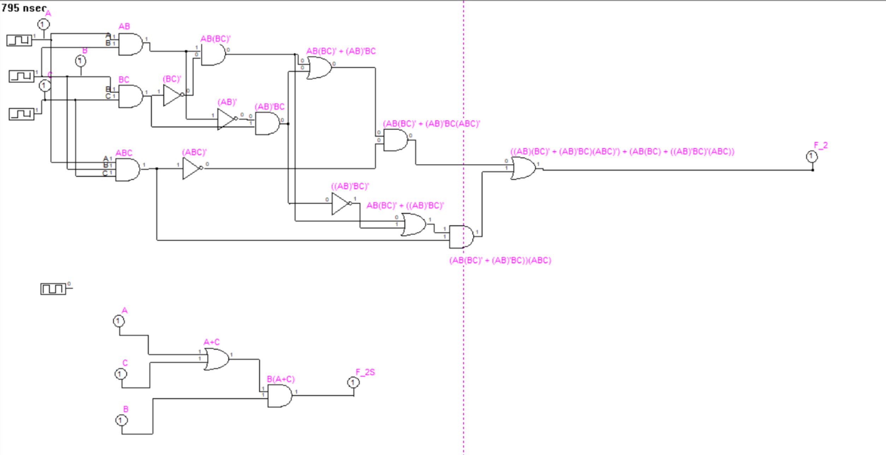
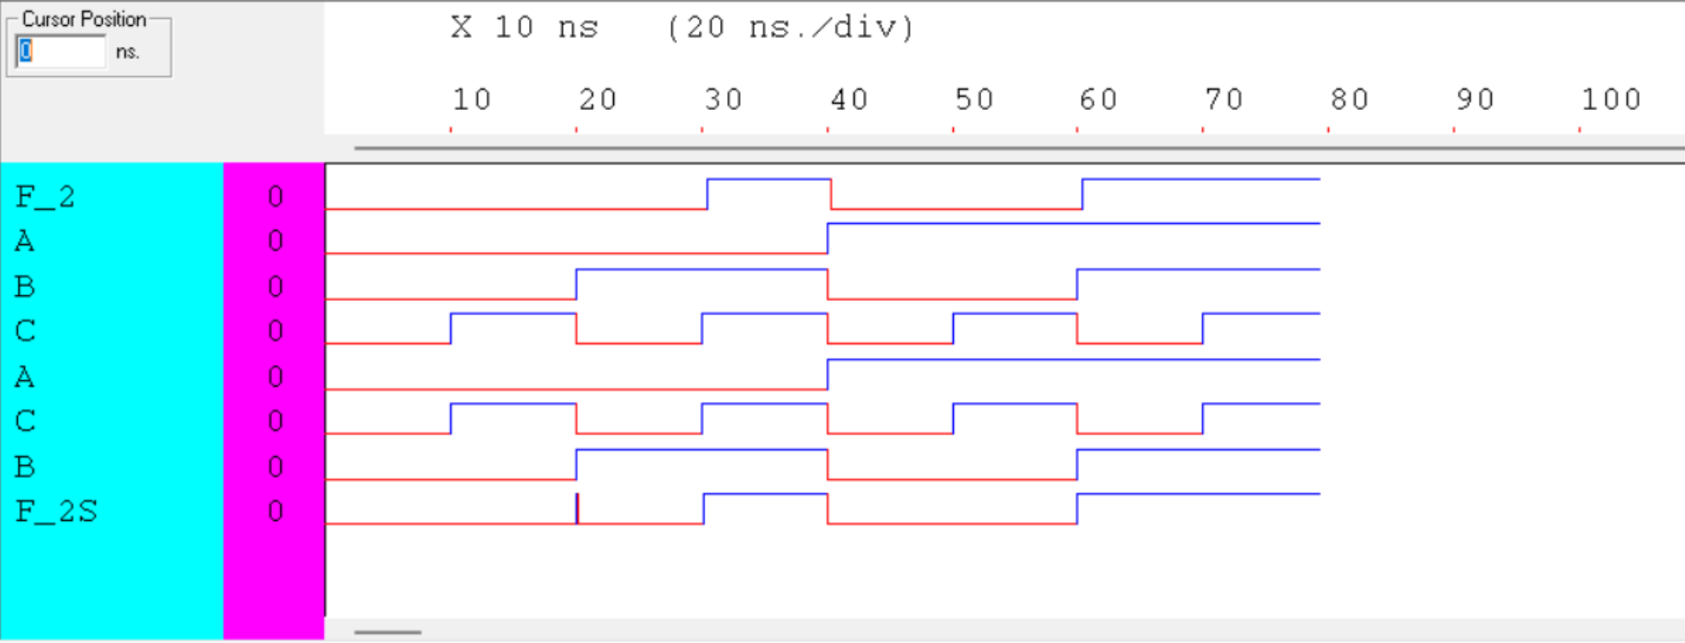

Conclusion
In this lab we learned more about the XOR definition which is . We also became familiar with using the clock component in SimUAid and with running a timed simulation.

